

Applied Machine Learning
14.07.2024
─
Group One
1. Remmy Bisimbeko - B26099 - J24M19/011
2. Racheal Econia - B26253 - J24M19/016
4. Namakula Martha Frances - B26317 - J24M19/022
5. Ntwasi Gideon - B26098 - J24M19/010

1. Introduction
The drastic rise of digital transactions has transformed the financial realm, rendering credit cards a ubiquitous and user-friendly instrument for contemporary consumers. Nonetheless, this pervasive adoption also presents obstacles, with the surge in fraudulent endeavours posing a substantial challenge to both financial organisations and cardholders. Identifying and thwarting credit card fraud have become imperative in preserving the integrity of financial systems and safeguarding the security of individuals.
Leveraging Machine Learning for Robust Credit Card Fraud Detection. This study concentrates on harnessing machine learning techniques to construct an efficacious and resilient model for the identification of fraudulent credit card transactions. By tapping into the potency of advanced analytics, we aspire to augment the existing fraud detection frameworks, empowering financial institutions to identify and impede fraudulent activities with heightened accuracy and efficiency.

Goals
To effectively detect anomalies in transaction data through robust feature engineering which involves extracting pertinent features which enrich the model's ability to discern fraudulent activities. Following feature extraction, rigorous data EDA and preprocessing techniques will be applied. This includes handling missing values, outliers, and standardising features through methods like scaling, imputation, and outlier removal. By ensuring the data is clean and standardised, the model can better learn and generalise from the patterns present in the transaction data.
We ought to select a suitable machine learning algorithm through thorough model selection. Options like logistic regression, decision trees, random forests, and neural networks to be evaluated based on performance metrics such as precision, recall, and F1-score. Hyperparameter tuning further optimises the chosen model using techniques like grid search or random search, thereby enhancing effectiveness in anomaly detection.
To evaluate metrics such as precision, recall, and ROC-AUC and carefully assess the model's performance on both training and validation data, ensuring its reliability in detecting anomalies. Finally, to deploy the model in a real-time environment, emphasising low latency and scalability, with continuous monitoring to maintain and improve its performance over time.

Detecting Fraudulent Credit Card Transactions Based on Credit Card Data

Milestone
1.1. Problem Statement
Credit card fraud is the unauthorised use of a debit or credit card to make purchases or withdraw cash.
The Persistent Challenge of Credit card fraud is an enduring and dynamic predicament that can precipitate considerable financial losses for both credit card companies and their clientele. Conventional rule-based systems for fraud detection may grapple to maintain pace with the intricate tactics employed by fraudsters. Consequently, there is a compelling need for innovative and malleable approaches that can effectively identify fraudulent transactions in real-time, mitigating financial losses and preserving the trust and confidence of cardholders.
1.2. Objectives
The primary objectives of this study are:
1. To construct a Machine Learning Model, by building a sturdy machine learning model capable of detecting fraudulent credit card transactions with heightened accuracy.
2. To enhance detection efficiency, through augmenting the efficiency of fraud detection mechanisms to diminish false positives and negatives, improving overall system performance.
3. To investigate feature importance, by identifying and analysing the most impactful features contributing to fraud detection, providing insights into the attributes of fraudulent transactions.
4. To assess Model Generalization, by evaluating the model's ability to generalise well on unseen data, ensuring its dependability in real-world scenarios.

1.3. Hypothesis
Our Hypotheses
We hope that leveraging cutting-edge machine learning algorithms, such as ensemble methods and anomaly detection techniques, will significantly bolster the accuracy and efficiency of credit card fraud detection. By training the model on a comprehensive dataset encompassing both normal and fraudulent transactions, we expect the model to learn intricate patterns and anomalies, empowering it to distinguish between legitimate and fraudulent activities effectively. Furthermore, we hypothesise that identifying key features contributing to fraud detection will provide invaluable insights for enhancing the overall security of credit card transactions.
2. Importation of Important Libraries
When it comes to predicting data trends, having the right tools is just as important as understanding the algorithms behind them. Choosing the right libraries can make a huge difference in how smoothly you can manipulate data, create visualisations, and select models. In this section, we’ll dive into some key libraries that are essential for building strong predictive models. From handling data to fine-tuning model parameters, these libraries are the backbone of an efficient and insightful data prediction journey

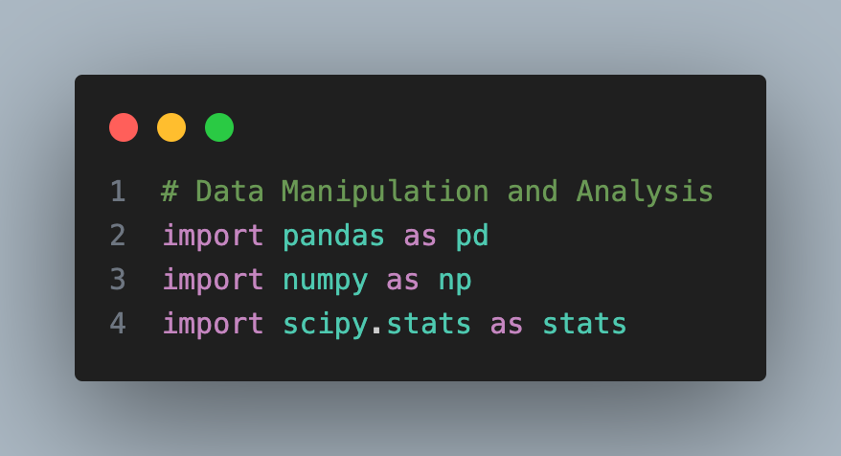

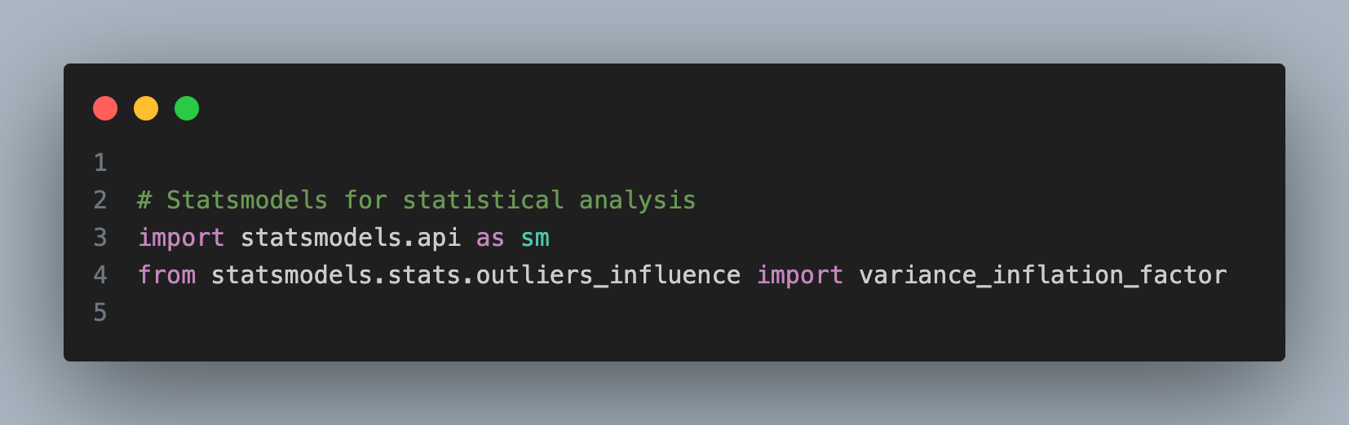
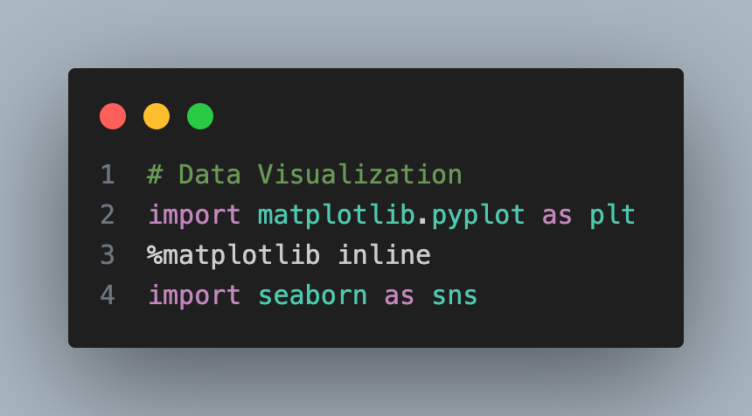

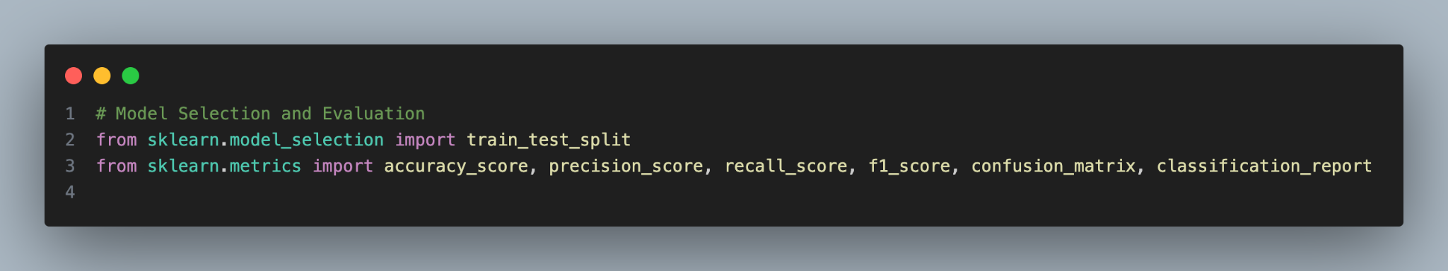

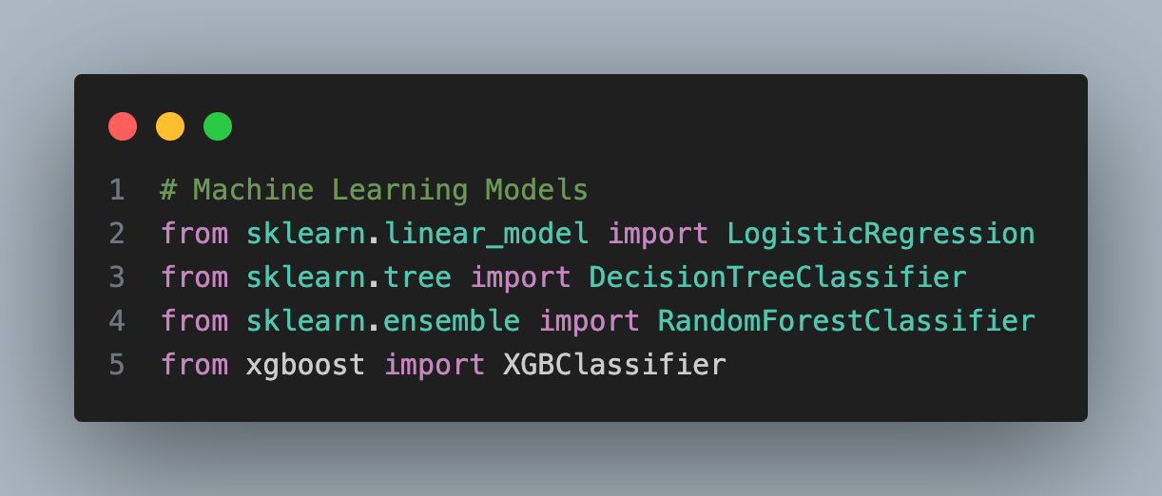

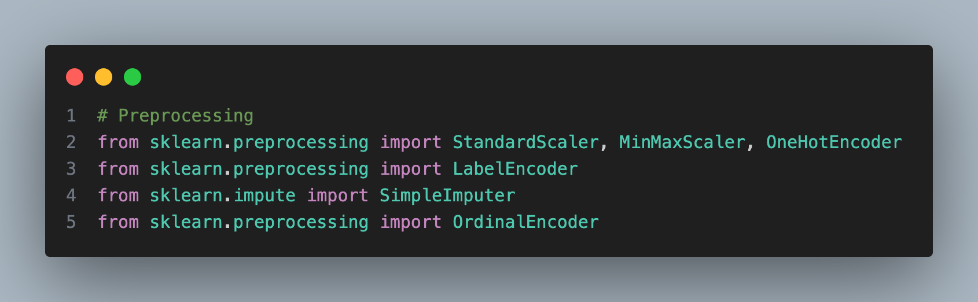

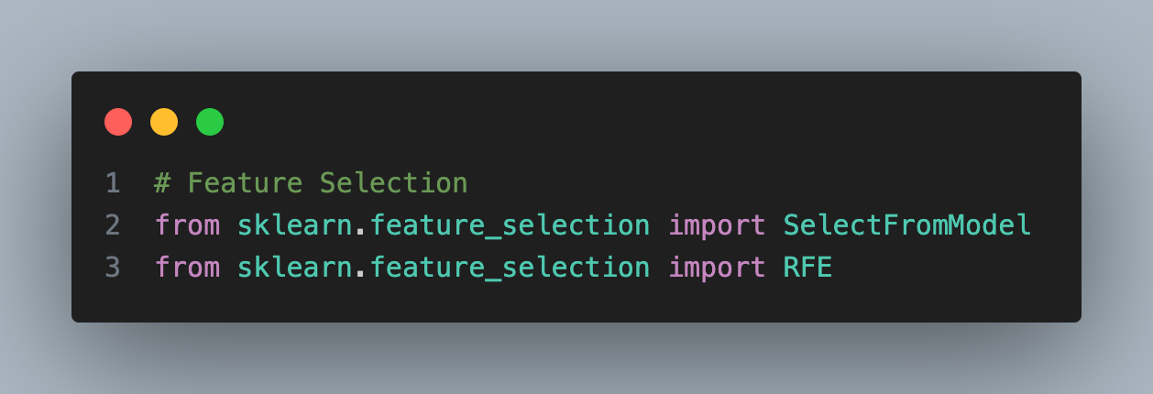
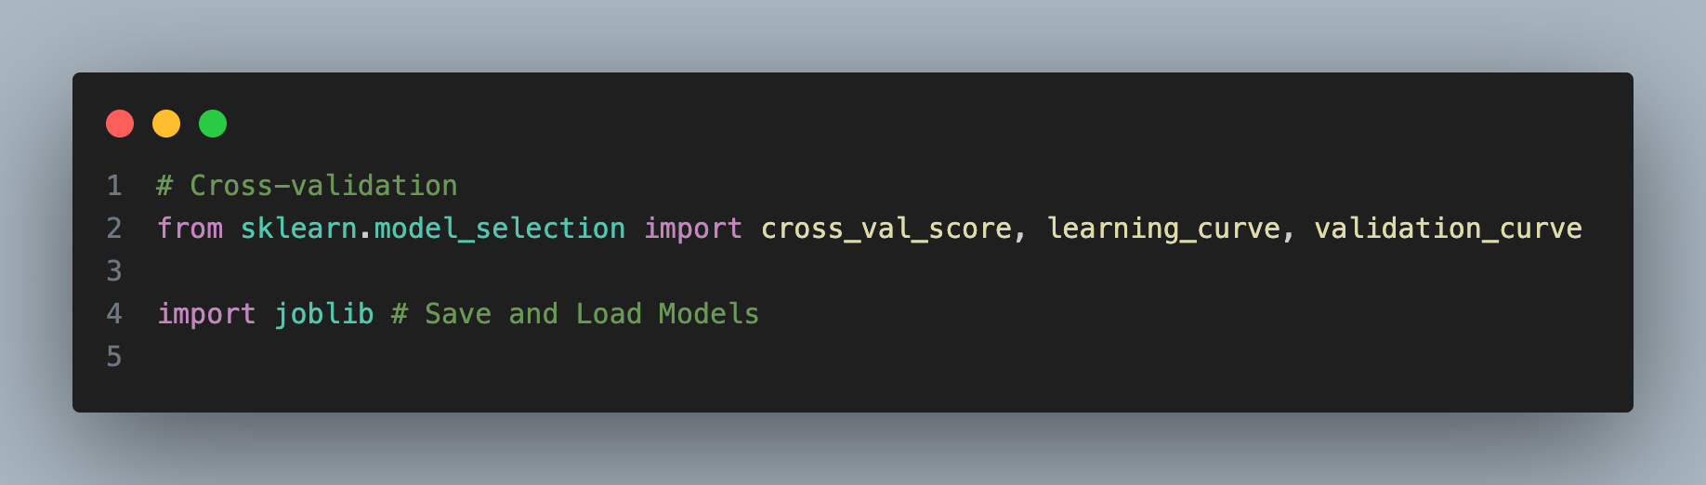

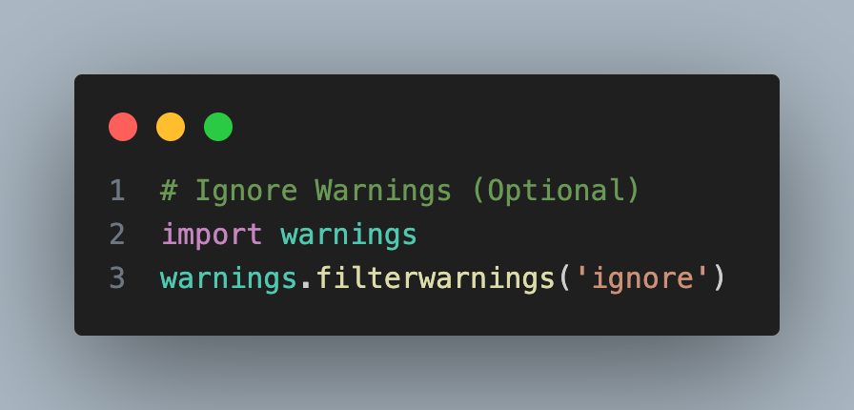

3. Data Loading & Preprocessing
This section is a crucial phase in developing a machine learning model for credit card fraud detection as it involves acquiring the dataset, understanding its structure, and preparing the data for further analysis and model training.

3.1.1 Acquiring the 'creditcard.csv' Dataset
In this section we access the dataset on Kaggle: https://www.kaggle.com/datasets/mlg-ulb/creditcardfraud. Download the dataset and load it into our data analysis environment Jupyter Notebook and explore the data to understand its structure and features.
3.1.2 Loading the 'creditcard.csv' Dataset
Here we use a data manipulation library Pandas in Python to load the dataset into a DataFrame. And as well verify that the data has been loaded correctly by inspecting the first few rows.

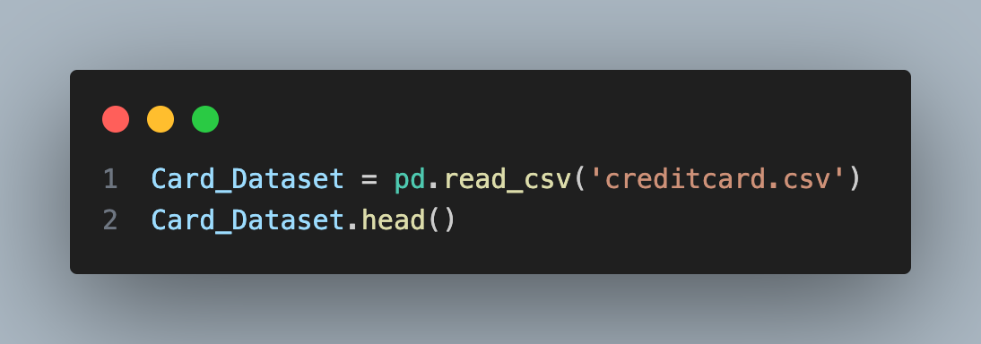

3.2. Data Exploration & Analysis
3.2.1 Exploring the 'creditcard.csv' Dataset
In this subsection we check the dimensions of the dataset i.e the number of rows and columns, explore the basic statistics of numerical features i.e mean, median, standard deviation and as well gain an understanding of the distribution of the target variable in fraudulent or non-fraudulent transactions. And our statistical description of the data is as follows: count 11.000000, mean 79.872727, std 112.345485, min 2.690000, 25% 4.335000, 50% 40.800000 ,75% 108.350000 and max 378.660000
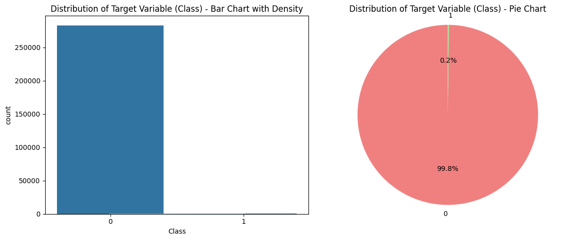

3.2.2. Checking & Handling Missing values and Duplicate values in the 'creditcard.csv' dataset
This section entails detecting and fixing data errors such as missing values, duplicates, outliers and inconsistent formatting. The Dataset has 8 rows and 31 columns, and there are no missing values.
4. Handling Class Imbalance
The selection of the optimal technique to manage imbalanced classes is influenced by various factors and often requires some trial and error. Nevertheless, considering the nature of the highly imbalanced credit card data, we chose to employ RandomOverSampling (SMOTE-ENN), which combines oversampling and undersampling techniques, and Adaptive Synthetic Sampling Method (ADASYN) techniques. These methods assist in balancing the class distribution while mitigating the potential information loss associated with pure undersampling.

4.1.2. Synthetic Minority Over-sampling Technique(SMOTE) on Logistic Regression Model
This technique generates synthetic samples for the minority class (oversampling) and then cleans the data by removing instances that are close to the majority class (undersampling).
From the information provided in the table above and considering the trade-offs between precision and recall for fraud detection, we recommend the Base Model with Logistic Regression and the Base Model with Decision Tree under Baseline Models, we as well recommend the Random Forest Model with SMOTE and the XGBoost Model with SMOTE because of the following reasons:
1. The Base Model with Logistic Regression
- High Precision, while the recall of the base model is lower (0.58), the precision is relatively high (0.72). This means that, of the instances predicted as fraudulent, a substantial portion is indeed true positives.
- High Accuracy, the base model has a high overall accuracy (0.99), which suggests good performance in terms of correctly classifying both fraudulent and non-fraudulent transactions.
- Balanced F1 Score, the F1 score (0.64) is a balanced metric that considers both precision and recall. While it's not as high as precision or accuracy, it provides a combined measure of the model's performance.

2. The Base Model with Decision Tree
- Higher Precision in the Base Model, the base model has higher precision, which is crucial in fraud detection scenarios to minimise false positives.
- Balanced Trade-off, the base model offers a balanced trade-off between precision and recall, aligning well with specific application requirements.
- Resource Constraints, the base model could be preferred if there are resource constraints, as it is often computationally less intensive than over-sampling techniques.
- Data Characteristics, as the base data already performs well and represents the fraud patterns adequately, additional techniques may not provide significant improvements.
- Interpretability, Decision Trees, being simple and interpretable, might be preferred for scenarios where model interpretability is crucial.

3. The Random Forest Model with SMOTE
- Enhanced Recall: Among the various techniques, SMOTE demonstrates the highest recall. This is particularly important in fraud detection, as it reflects the model's ability to identify a greater share of actual fraudulent transactions. A higher recall indicates that the model is more effective at spotting positive fraud cases.
- Balanced Precision and Recall: Although Random Over Sampling shows slightly better precision, SMOTE offers a more balanced approach between precision and recall. In the context of fraud detection, achieving this balance is vital to reduce both false positives and false negatives. SMOTE effectively strikes this compromise.
- Superior F1 Score: SMOTE also achieves the highest F1 Score, which evaluates both precision and recall. This suggests that the model performs well in balancing the two metrics. A higher F1 Score indicates that the model is adept at managing imbalanced datasets, which is typical in fraud detection situations.
4. The XGBoost Model with SMOTE
- Balanced Precision and Recall: SMOTE provides an effective balance between precision and recall, which is essential in fraud detection. While high precision helps reduce false positives, strong recall ensures that a significant number of actual fraudulent transactions are identified.
- F1 Score: SMOTE achieves a relatively high F1 Score, which combines both precision and recall. This reflects the model's solid overall performance in balancing the need to minimise both false positives and false negatives.
- Improvement in Recall: Compared to the base model, SMOTE demonstrates a notable improvement in recall. This indicates that SMOTE effectively addresses the issue of imbalanced data by generating synthetic samples for the minority class, thus enhancing the model's capacity to detect fraudulent transactions.
- After testing various techniques and parameters to determine the most effective approach for detecting fraudulent credit card transactions using the 'creditcard.csv' dataset, we decided to proceed with hyperparameter tuning for improved performance. This step is vital for optimising our machine learning models. Below are the hyperparameters we considered for tuning: Logistic Regression Model with Base Model, Decision Tree Model with Base Model, Random Forest Model with SMOTE, and XGBoost Model with SMOTE.

5. Hyperparameter Tuning
5.1. Hyperparameter Tuning Logistic Regression Model with Base Model
i. C which is the (Inverse of regularisation strength)
Searching for the optimal value for C. Important to note here higher values can lead to overfitting, while lower values can result in underfitting.
ii. Penalty
Choosing between L1 and L2 regularisation. Depending on the nature of our data and whether feature selection is important.
The ROC Curve with an Area Under the Curve (AUC) of 0.89 suggests that the model has a strong ability to discriminate between the positive and negative classes. The higher AUC value indicates good performance in terms of the true positive rate and false positive rate trade-off.
On the other hand, the PR Curve with an AUC of 0.56 reflects a moderate precision-recall trade-off. This means that while the model performs reasonably well, there is room for improvement, especially in optimising precision and recall simultaneously.
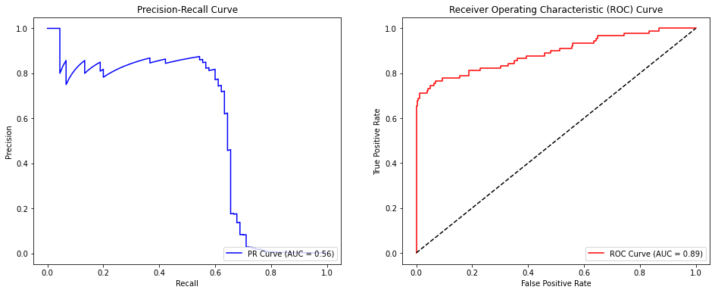

5.1.1. Cross Validation for Logistic Regression Model with Base Model
To guarantee that the hyperparameter values generalise effectively to unseen data, we implemented cross-validation. This technique allows us to assess the model's performance on multiple subsets of the data, providing a more robust estimate of its ability to handle new, previously unseen instances.
5.2. Hyperparameter Tuning Decision Tree Model with Base Model
i. Max Depth
Limiting the maximum depth of the tree to control overfitting.
ii. Min Samples Split
Setting the minimum number of samples required to split an internal node.
iii. Min Samples Leaf
Defining the minimum number of samples required to be at a leaf node.

The ROC Curve's AUC of 0.86 indicates that the model has a good ability to discriminate between the positive and negative classes. The higher AUC value suggests a favourable balance between the true positive rate and the false positive rate
Meanwhile, the PR Curve's AUC of 0.63 implies a moderate precision-recall trade-off. The model performs reasonably well, but there is room for improvement, particularly in optimising precision and recall simultaneously.

5.2.1 Cross Validation for Decision Tree Model with Base Model
We employed cross-validation in order to ensure that the hyperparameter values generalise well to unseen data.
5.3. Hyperparameter Tuning Random Forest Model with SMOTE
i. Number of Trees (n_estimators)
Tuning the number of trees in the forest.
ii. Max Features
Setting the maximum number of features considered for splitting a node.
iii. Max Depth
Limiting the maximum depth of individual trees.
The Precision-Recall Curve, with an Area Under the Curve (AUC) of 0.83, demonstrates the trade-off between precision and recall across different thresholds. A higher AUC indicates a better balance between precision and recall, showcasing the model's ability to correctly identify positive instances while minimising false positives.
On the other hand, the ROC Curve, with an AUC of 0.96, illustrates the trade-off between true positive rate (sensitivity) and false positive rate across various classification thresholds. The higher AUC in the ROC Curve signifies a strong ability of the model to discriminate between positive and negative instances, showcasing robust performance.
In summary, these curves complement each other, providing a comprehensive evaluation of the model's classification performance. A high AUC in both the PR Curve and ROC Curve suggests that the model performs well in terms of precision, recall, sensitivity, and specificity, indicating its effectiveness in handling the classification task.
5.3.1. Cross Validation for Random Forest Model with SMOTE
We employed cross-validation in order to ensure that the hyperparameter values generalise well to unseen data.
5.4. Hyperparameter Tuning XGBoosting Model with SMOTE

i. Learning Rate (eta)
This controls the step size during optimization. Lower values require more trees but can improve generalisation.
ii. Number of Trees
Tuning the number of boosting rounds.
iii. Max Depth
Maximum depth of a tree.
iv. Subsample
Fraction of observations to be randomly sampled for each tree.
The ROC Curve with a high AUC of 0.97 indicates robust discrimination power across various classification thresholds. This suggests a strong ability to differentiate between positive and negative instances.
The PR Curve with an AUC of 0.69, while lower in comparison, is still reasonable and may be particularly informative in scenarios where the positive class is of greater interest, and imbalances exist.
In summary, both curves provide valuable insights into different aspects of the model's performance. The high ROC AUC indicates overall strong performance, while the PR Curve AUC offers a nuanced view, especially in situations where class imbalances play a significant role. Consideration of both metrics provides a more comprehensive understanding of the model's effectiveness in different operational contexts.
5.4.1. Cross Validation for XGBoosting Model with SMOTE
To validate the hyperparameter values and ensure they perform well on unseen data, we utilised cross-validation. This approach allows us to evaluate the model's performance on multiple subsets of the data, thereby providing a more reliable estimate of its ability to handle new, previously unseen instances.
6. Model Selection
Based on our analysis of the credit card data, we recommend the following two models for detecting fraudulent credit card transactions:
1. Random Forest Model with SMOTE
- PR Curve (AUC = 0.83) and ROC Curve (AUC = 0.96) indicate strong performance.
- Cross Validation Mean AUC = 0.97, demonstrating consistent performance across different folds.
- Random Forest models are known for their robustness and effectiveness in handling complex datasets.
2. XGBoost Model with SMOTE
- PR Curve (AUC = 0.69) and ROC Curve (AUC = 0.97) both show strong performance, especially in terms of ROC AUC.
- Cross Validation Mean AUC = 0.98, indicating consistent and high performance.
- XGBoost is an ensemble learning algorithm known for its accuracy and efficiency, often performing well in various scenarios.

Reasons for our Selection
- Both the Random Forest and XGBoost models exhibit high AUC scores in both the Precision-Recall (PR) and Receiver Operating Characteristic (ROC) curves. This indicates that these models strike a favourable balance between precision and recall, as well as true positive rate and false positive rate.
- The incorporation of SMOTE (Synthetic Minority Over-sampling Technique) in the Random Forest and XGBoost models suggests a concerted effort to address class imbalance, which is a critical consideration in fraud detection where positive cases (frauds) are often scarce.
- Furthermore, the consistently high cross-validation results for both models demonstrate their ability to generalise well to different subsets of the data, instilling confidence in their performance on unseen instances.
While the XGBoost model has a slightly higher mean AUC, the choice between Random Forest and XGBoost may depend on factors like interpretability, computational efficiency, and ease of implementation in the production environment.
We recommend further evaluation of these models on additional metrics like precision, recall, F1-score and consider the specific requirements and constraints of the deployment environment before making a final decision.

7. Conclusion
Our evaluation of different models for detecting fraudulent credit card transactions has yielded insightful results. Among the models considered,

1. Logistic Regression Model
- While the Logistic Regression model shows a respectable ROC AUC of 0.89, the PR AUC is relatively low at 0.56.
- The Cross Validation Mean AUC of 0.91 suggests that the model generalises well across different subsets of the data.
- Overall, the Logistic Regression model may not be the top choice due to the lower PR AUC, which is critical in fraud detection scenarios where identifying true positives is crucial.

2. Decision Tree Model
- The Decision Tree model demonstrates decent performance with a ROC AUC of 0.86 and a PR AUC of 0.63.
- The Cross Validation Mean AUC of 0.88 indicates good generalisation capabilities.
- However, compared to the Random Forest and XGBoost models, the Decision Tree model's performance appears to be slightly lower.

3. Random Forest Model with SMOTE
- The Random Forest model, especially with SMOTE to handle class imbalance, shows strong performance with a PR AUC of 0.83 and a high ROC AUC of 0.96.
- The Cross Validation Mean AUC of 0.97 suggests consistent and robust performance across different subsets of the data.
- This model is a strong candidate for detecting fraudulent transactions, considering its balanced performance in both PR and ROC curves.

4. XGBoost Model with SMOTE:
- The XGBoost model, with SMOTE for handling class imbalance, exhibits strong performance with a PR AUC of 0.69 and an impressive ROC AUC of 0.97.
- The Cross Validation Mean AUC of 0.98 indicates high and consistent generalisation performance.
- This model is a top contender, especially considering its high ROC AUC and overall strong performance.

Conclusion for Decision Makers
The Random Forest and XGBoost models with SMOTE augmentation emerge as the most promising algorithms for detecting fraudulent credit card transactions. While the XGBoost model slightly outperforms the Random Forest in terms of mean AUC, the final decision totally depends on factors such as interpretability, computational efficiency, and ease of implementation in the production environment.
It is, however, recommended to thoroughly evaluate the models on additional metrics and consider the specific requirements and constraints of the deployment environment before making a final decision. This comprehensive assessment will ensure the selected model not only delivers strong performance but also aligns with the practical needs and constraints of the real-world application.

